Mockito exercises
Exercise1:
Mocking and Stubbing
import org.junit.jupiter.api.Test;
import org.mockito.Mockito;
import static org.junit.jupiter.api.Assertions.assertEquals;
import static org.mockito.Mockito.when;
public class MyServiceTest {
@Test
public void testExternalApi() {
// Step 1: Create Mock Object
ExternalApi mockApi = Mockito.mock(ExternalApi.class);
// Step 2: Stub Method
when(mockApi.getData()).thenReturn("Mock Data");
// Step 3: Inject Mock into Service
MyService service = new MyService(mockApi);
// Step 4: Call Service Method
String result = service.fetchData();
// Step 5: Verify Result
assertEquals("Mock Data", result);
}
}

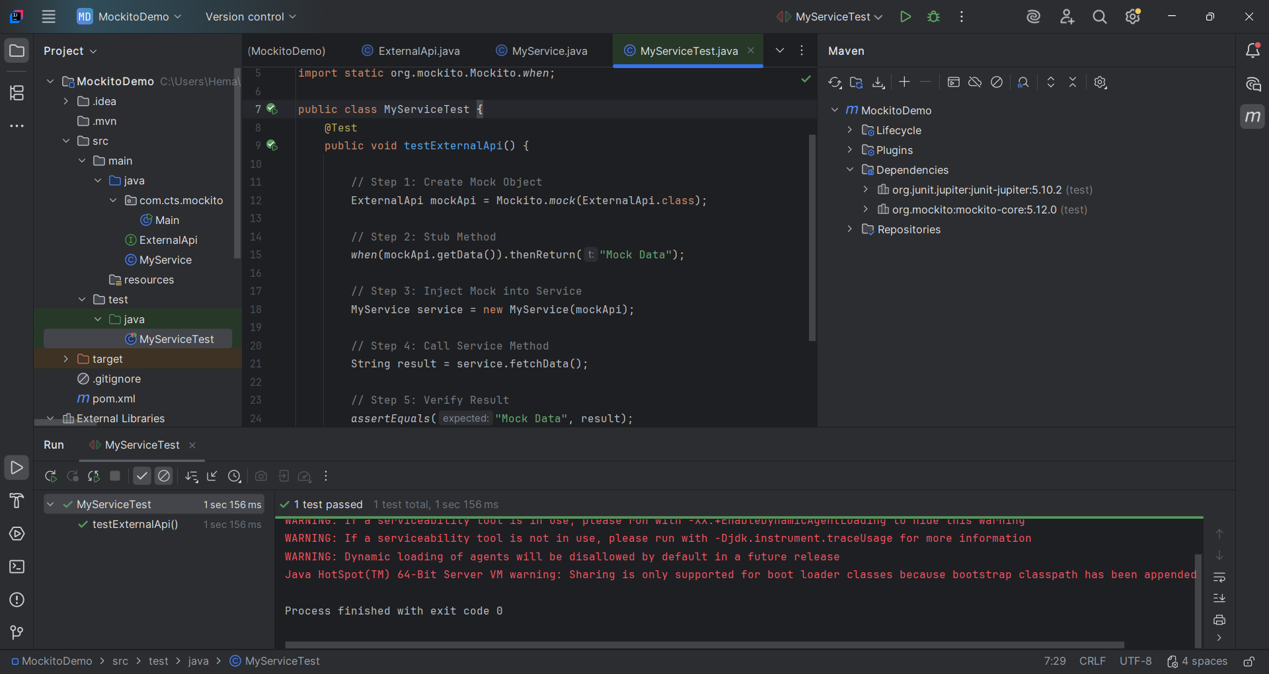
Exercise 2:
Verifying interactions
import static org.mockito.Mockito.verify;
@Test
public void testVerifyInteraction() {
// Create Mock Object
ExternalApi mockApi = Mockito.mock(ExternalApi.class);
// Inject Mock
MyService service = new MyService(mockApi);
// Call Method
service.fetchData();
// Verify Method Call
verify(mockApi).getData();
}
